EE4902 Part 2 Assignment 1

Name: Lim Jia Song John

Matriculation No.: U1321554J

# Is **Gaussian smoothing operator** a linear or non-linear filter? Explain your answer and illustrate it with images.

The Gaussian smoothing operator is a linear filter. The principle of superposition holds. i.e. if input signal is , then the output signal is for any constants and .

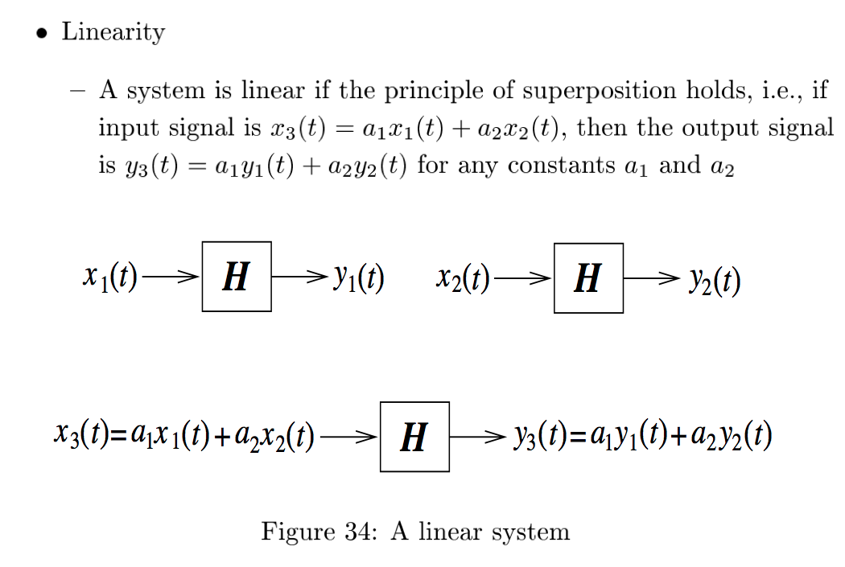

Figure ‑ Linear transformation

With respect to Figure 1‑1, is the original image, while is the linear scaling coefficient that is applied to the image to obtain the contrast stretched image. is the Gaussian blur. When x is transformed by H, it yields y, a Gaussian blurred image.

To illustrate it with images, linearly scaling the original image pixels will result in the same scaling effect on the Gaussian blurred image. The two images used are one that has been contrast stretched and one that has not. The contrast stretched image has a larger dynamic range and appears brighter than the original one. After performing Gaussian blurring on the contrast image, the resulting image is also brighter than the Gaussian blurred original image. This shows that the Gaussian blur is indeed a linear filter.

|  |  |  |
| --- | --- | --- |
| Before Blurring | After Gaussian Smoothing | After Gaussian Smoothing |
| Original Image |  |  |
| Contrast stretched image |  |  |

# Is **median filter** a linear or non-linear filter? Show that it is or is not and illustrate it with images.

A median filter is a non-linear filter. It replacing the middle pixel by the median pixel in the neighborhood and is hence unaffected by linear scaling of the image pixels. This makes it particularly suitable for impulse noise. If the median filter were linear, applying a linear transformation to the image with the noise will result in a linear transformation to the noise pixels. However, the results show that applying a linear scaling onto the original image has little to no effect of the removal of the impulse noise.

Salt and pepper noise was applied to three different images: (1) the original image 92) a contrast stretched image and (3) a Gaussian blurred image. Whether the image is scaled or blurred, the median filter can remove the salt and pepper noise just as well.

|  |  |  |
| --- | --- | --- |
| Original image | Impulse Noise | After Median Filter |
| Original Image |  |  |
| Contrast stretched image |  |  |
| Gaussian Blurred Image |  |  |

# Explain how the **Laplacian of Gaussian (LoG)** operator can be implemented by 1D filters?

The LoG is implemented by first convoluting the original image with a Gaussian kernel.

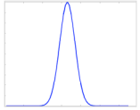

Afterwards, a Laplacian operator is performed on the Gaussian smoothed image.

The first step to doing this is to convolute the image with a 1-D first derivative filter in the x direction. This will obtain the zero crossing.

|  |  |  |  |
| --- | --- | --- | --- |
|  |  |  |  |
| Direction of Convolution  🡪 | * | |  |  |  |  |  |  | | --- | --- | --- | --- | --- | --- | | 66 | 65 | 62 | 63 | 64 | 62 | | 65 | 63 | 61 | 60 | 61 | 62 | | 55 | 60 | 58 | 57 | 56 | 55 | | 56 | 58 | 59 | 56 | 57 | 58 | | 57 | 60 | 61 | 60 | 57 | 56 | | 59 | 55 | 54 | 56 | 56 | 57 | |  |
| |  |  |  | | --- | --- | --- | | -1 | 2 | -1 | |

After the Laplacian is performed, the zero crossing is found. Performing a second derivative of a Gaussian will yield a Mexican hat operator, which is the Laplacian of Gaussian.

|  |  |  |  |  |  |
| --- | --- | --- | --- | --- | --- |
| Direction of convolution  ↓ | |  | | --- | | -1 | | 2 | | -1 | |  |
| |  |  |  |  |  |  | | --- | --- | --- | --- | --- | --- | | 66 | 65 | 62 | 63 | 64 | 62 | | 65 | 63 | 61 | 60 | 61 | 62 | | 55 | 60 | 58 | 57 | 56 | 55 | | 56 | 58 | 59 | 56 | 57 | 58 | | 57 | 60 | 61 | 60 | 57 | 56 | | 59 | 55 | 54 | 56 | 56 | 57 | | |  |